### OXFORD COGNITVE THERAPY CENTRE (OCTC) DIRECTIONS

**By Car:**

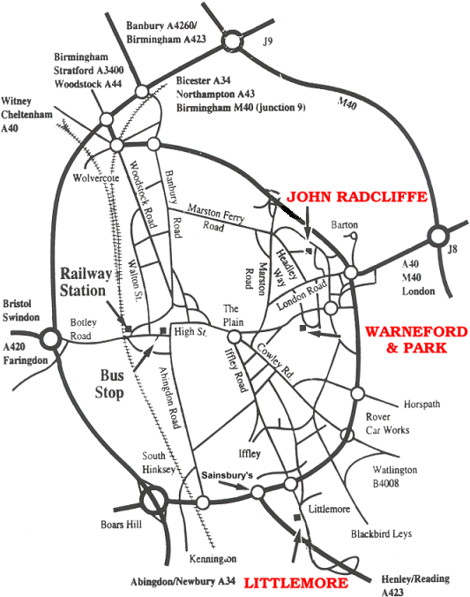

The Warneford Hospital is in Headington, 2 ½ miles east of Oxford City centre. It is reached easily from the M40.

* From the east, Junction 8 or Junction 8a, take the A40 then A420 to Headington Centre and follow signs.
* From the north, Junction 9, take the A34 then A40 northern ring road to the Marston junction (B4150), then turn left onto the B4495 towards Headington and follow signs.

From the south and west, approach from the Eastern ring road and B4495.

See the next page for a more detailed map of the city.

**On Arriving at the Warneford Hospital Site:**

Cars can enter the Warneford Hospital Site off Roosevelt Drive (see below). If you do plan to park at the Warneford, a pay & display system is operational. The tariff for over 3.5 hours is £4 paid in coins with no change given. Please note if there are no spaces in the pay & display area, you can park in the permit holders only area, as long as you display a ticket accordingly.

OCTC is based within the Isis Education Centre, immediately to the left as you enter the Warneford Hospital site.

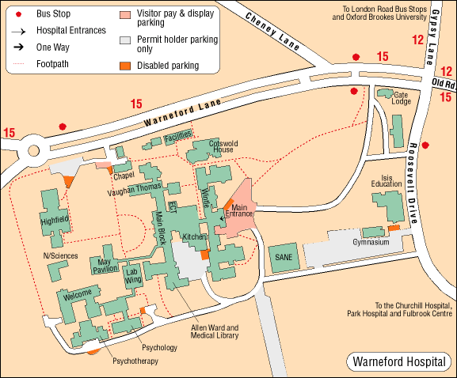

Entrance

to Warneford Hospital site

**OCTC**

**(within Isis Education Centre)**

**McInnes Room**

**(upstairs past main reception on the right)**



**The McInnes room can be found by entering the main Warneford Hospital reception, pictured above here and taking the first right past reception and immediately left up the stairs. The McInnes room will be found at the top of the stairs to the left.**

**Entrance to the Isis Education Centre**

